<dependency> <groupId>com.github.tomakehurst</groupId> <artifactId>wiremock-jre8</artifactId> <version>2.26.3</version> </dependency> <dependency> <groupId>io.rest-assured</groupId> <artifactId>rest-assured</artifactId> <version>4.3.0</version> </dependency> <dependency> <groupId>junit</groupId> <artifactId>junit</artifactId> <version>4.13</version> </dependency>

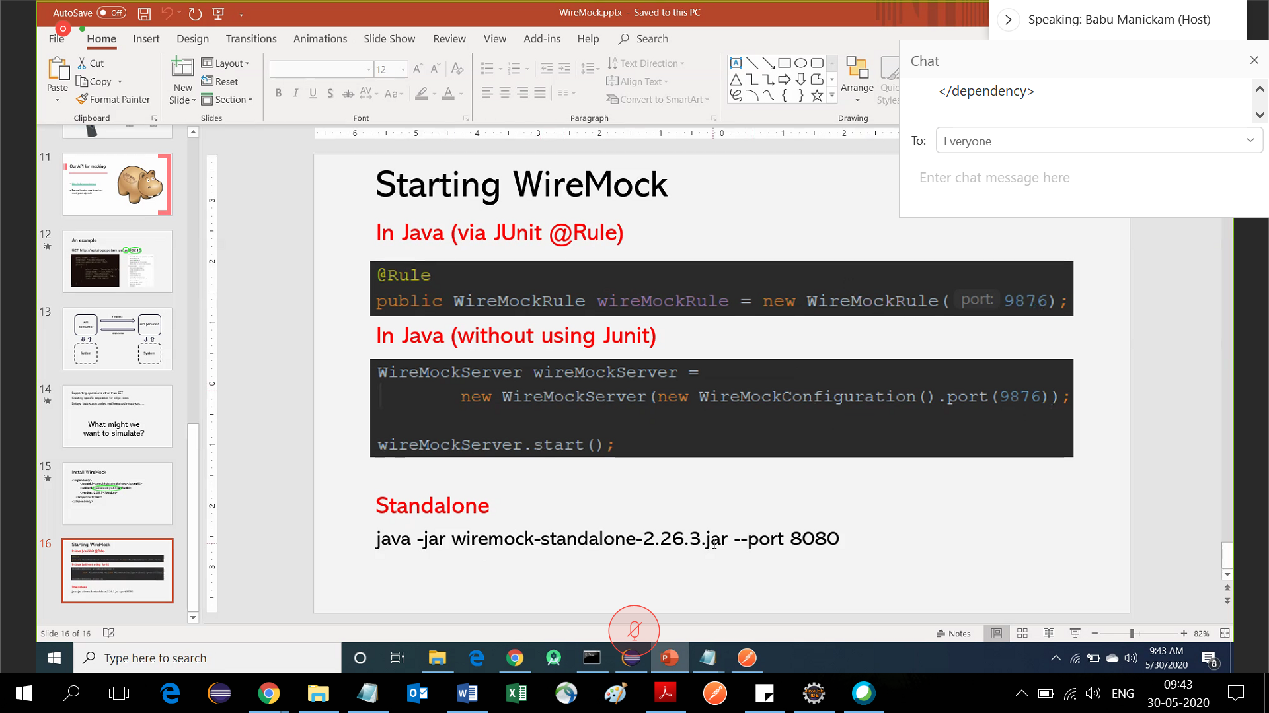

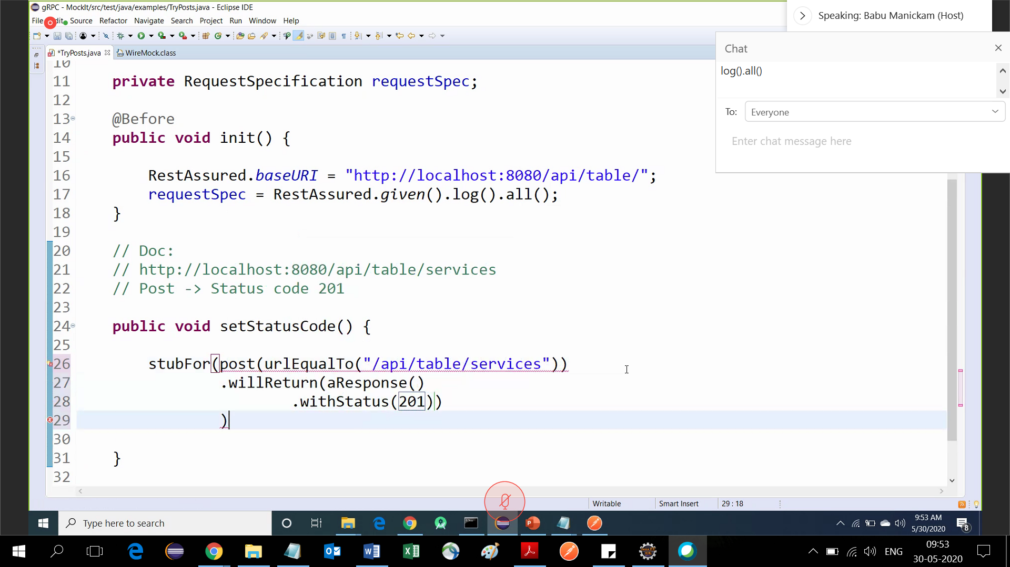

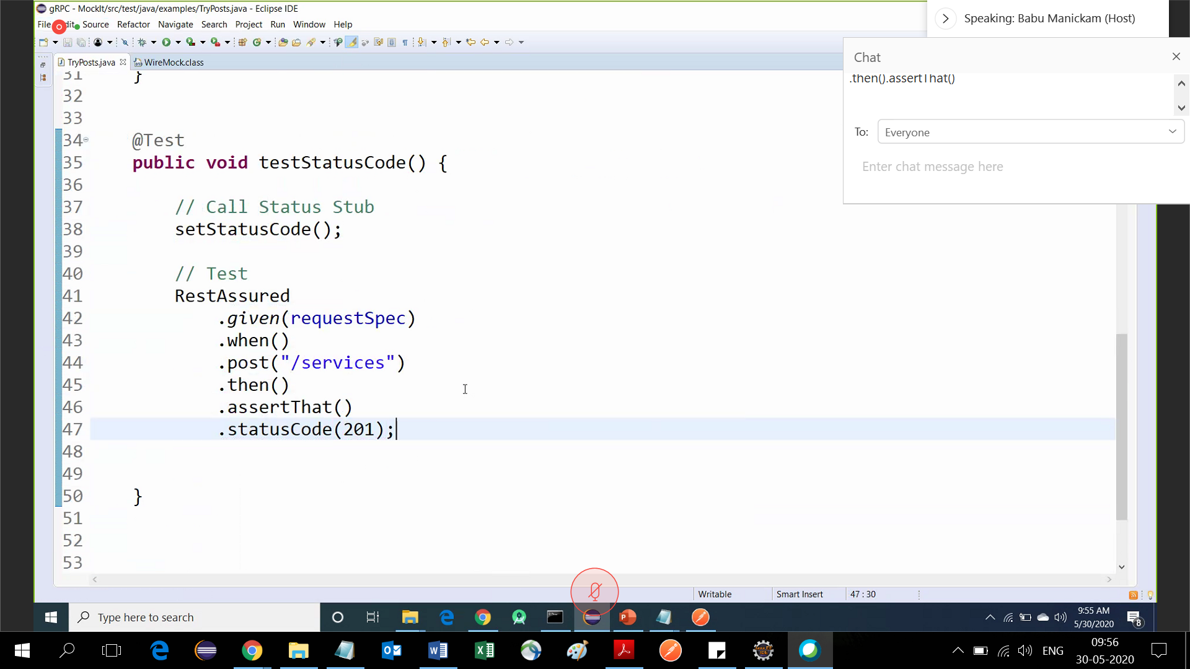

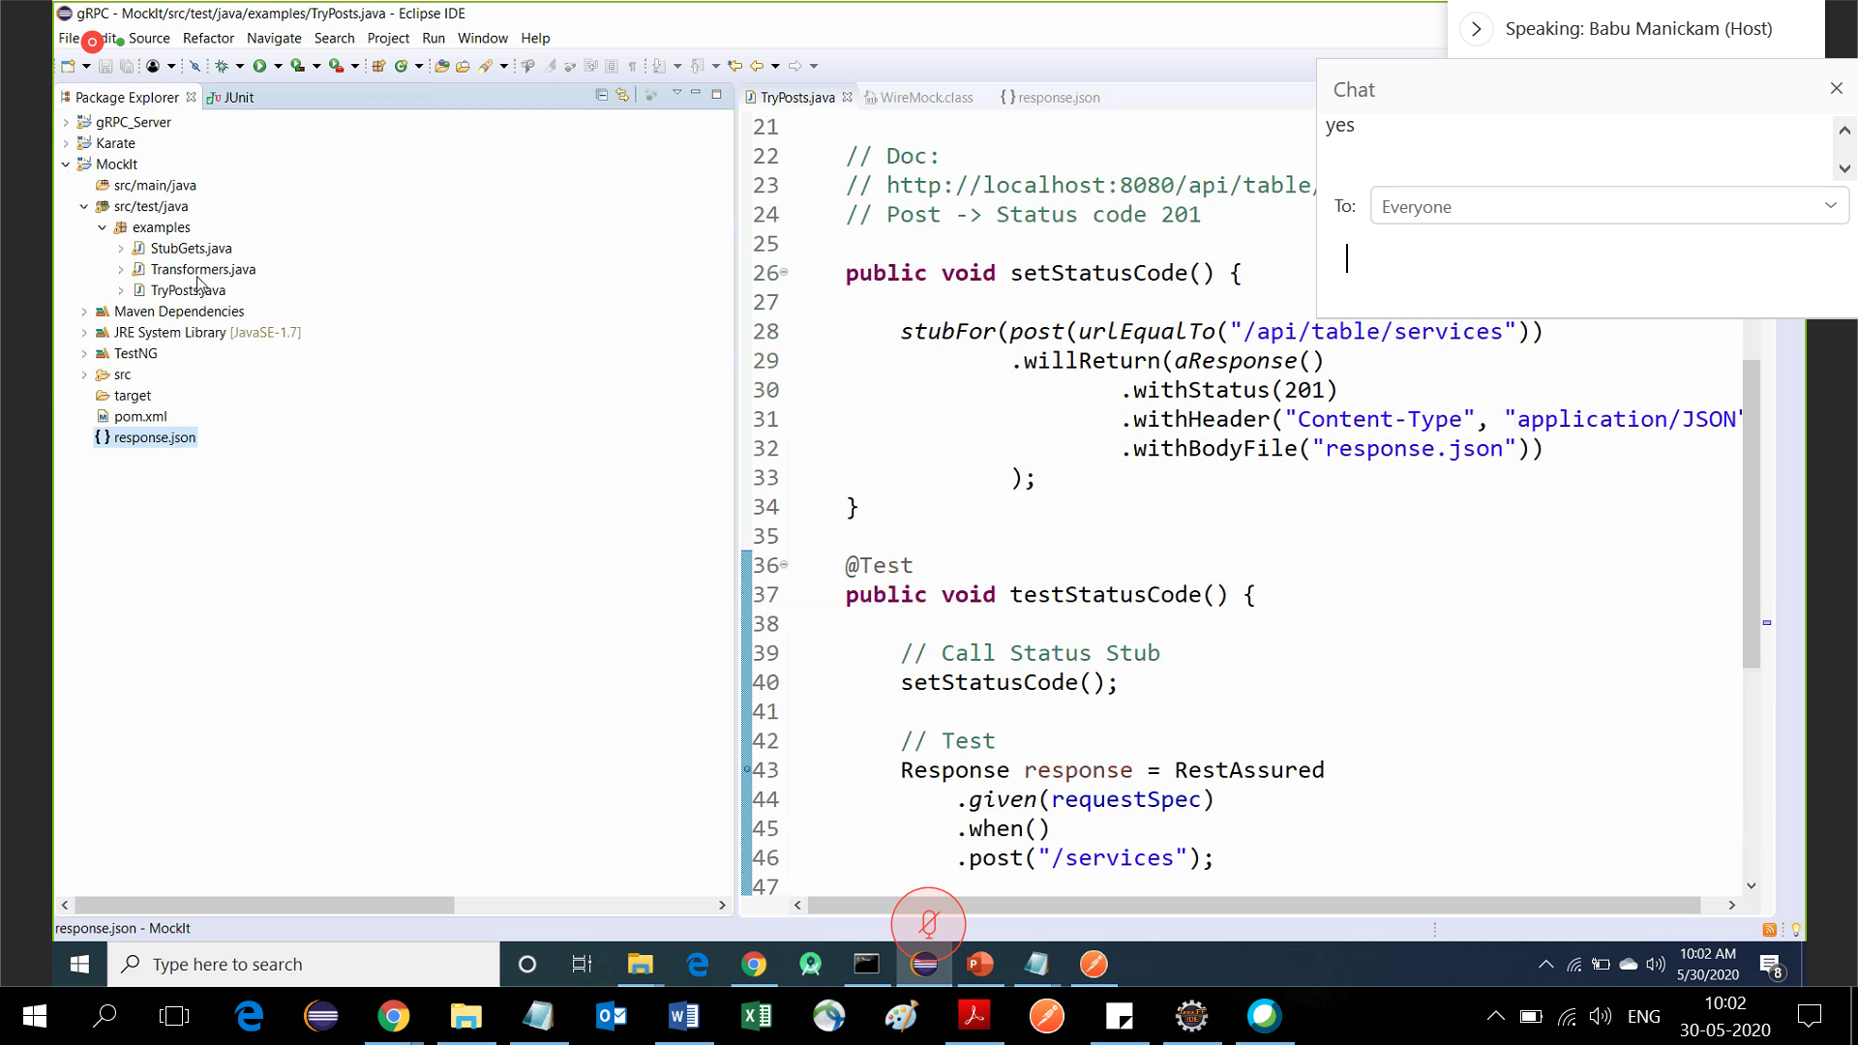

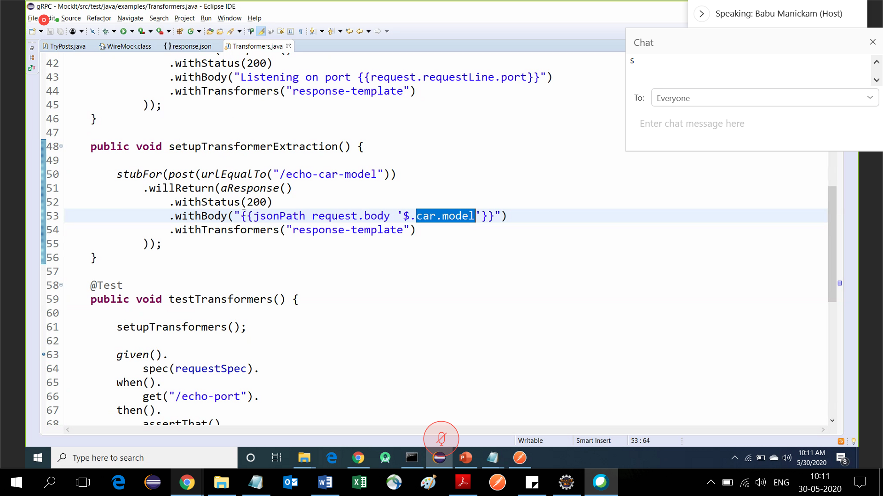

Graphql

